# Printf Scanf Assignment

**Mandatory:**

**Q1. WAP with**

**1a. function readdisplay() to read the following data types only one at a time at run time and to display.**

1. char type
2. integer type
3. char array of maximum 80 characters
4. short type
5. float type

**TestData:**

‘c’, 8978, “hello”, 8, 45.678

‘H’, 254, “hello Hi How”, 256, 145.2678

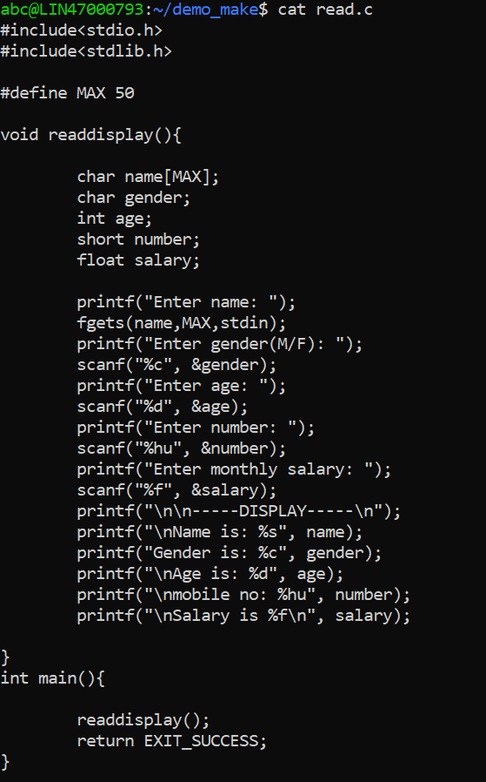

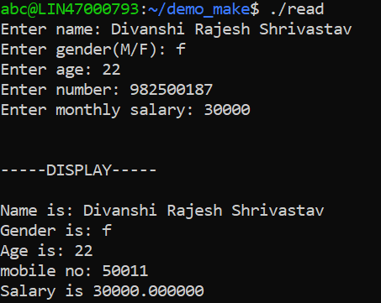

**1b. Create a copy of readdisplay() as function readdisplay2() with changes below**

* **Instead of reading 1 data at a time, read all inputs using a single scanf().**

**Test readdisplay2() by changing the read order. Do you observe any issue?**

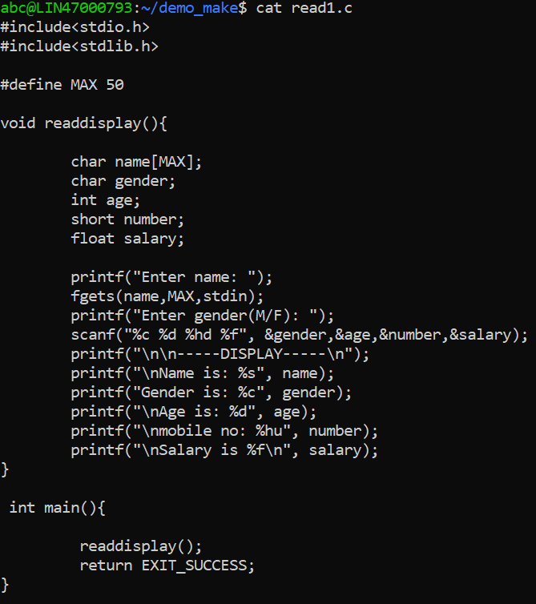

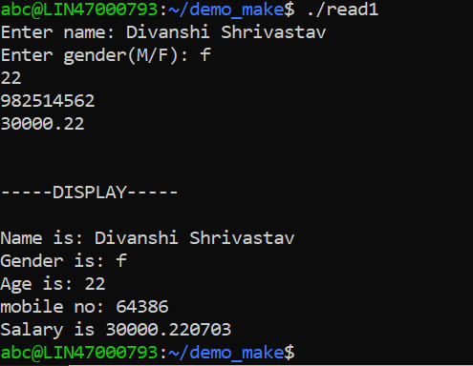

**1c. display the char array content in upper case.**

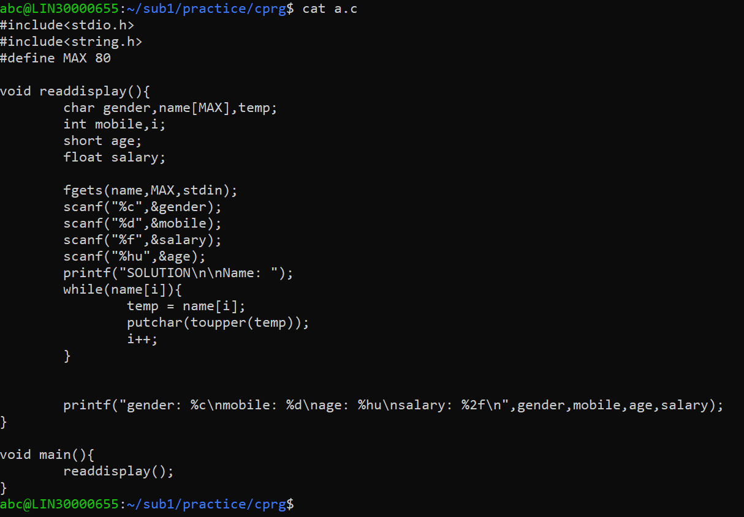

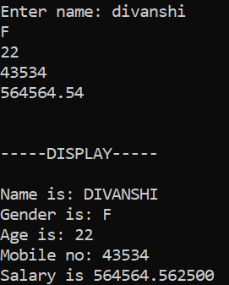

**1d. Add code to display the size of each data type mentioned in Q1a and sizeof the variables of each datatype (You may refer sample code in data_type_size.c )**

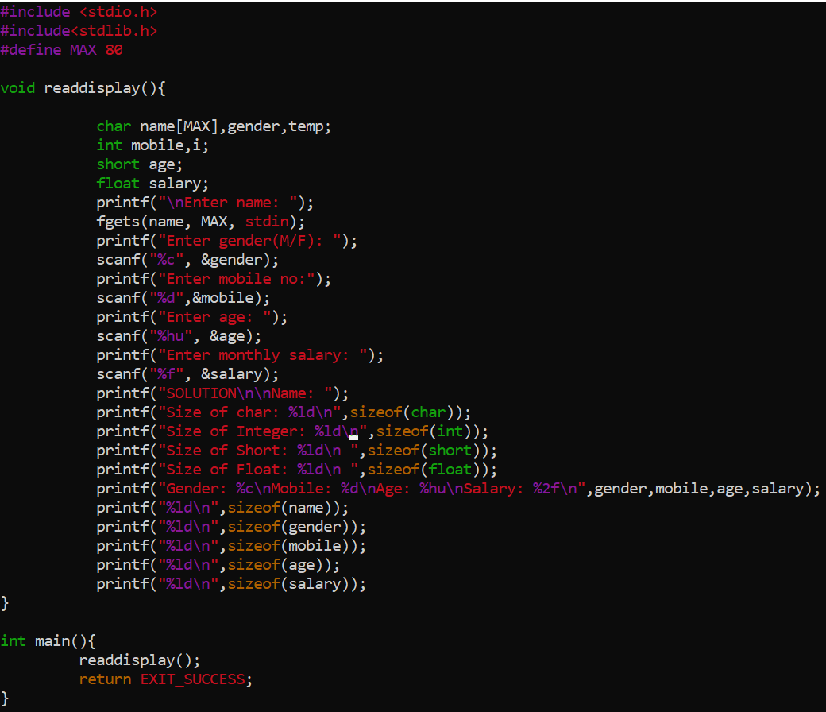

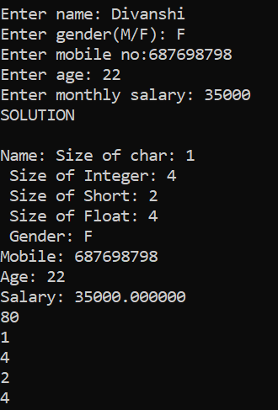

**Q2. Try to run the program with code snippet below. Check the output and analyse. Fix it to get correct result.**

#include<stdio.h>

int main()

{

unsigned long int ul = 200333333334340;

printf("value is:%d\n", ul);

return 0;

}

